CprE 3810: Computer Organization and Assembly-Level Programming

Project Part 2 Report

Team Members: James Gaule

Andy Eslick

Project Teams Group #:_________________________

Refer to the highlighted language in the project 1 instruction for the context of the following questions.

[1.a] Come up with a global list of the datapath values and control signals that are required during each pipeline stage.

IF → ID | ID → EX | EX → MEM | MEM → WB
ProgramCounter | Mem_WE | Mem_WE | MemToReg
Instruction | MemToReg | MemToReg | Reg_WE
 | Reg_WE | Reg_WE | HaltProg
 | HaltProg | HaltProg | DMem_Output
 | ALU_Operand1 | RS2 | ALU_Output
 | ALU_Operand2 | ALU_Output | Instruction
 | RS2 | Instruction
 | Instruction
 | ProgramCounter

[1.b.ii] high-level schematic drawing of the interconnection between components.

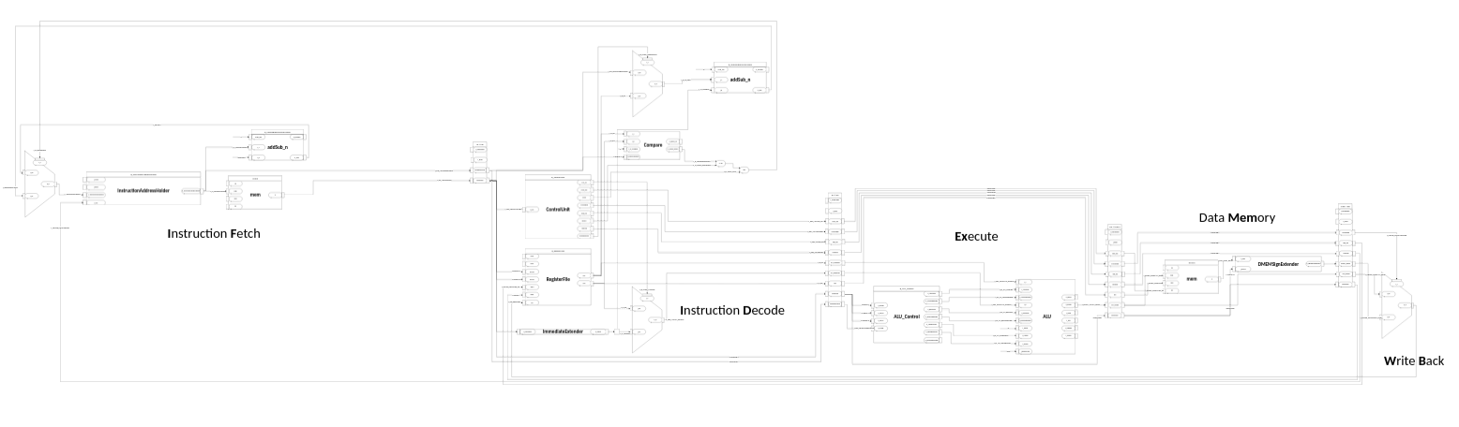

View the full diagram here:
https://iowastate-my.sharepoint.com/:u:/g/personal/esliandy_iastate_edu/IQAAiTNgo3T9RaB7BBPnPt7BAeMyRFAeHUjLhbH9OaDT_Yc?e=tu7gob

[1.c.i] include an annotated waveform in your writeup and provide a short discussion of result correctness.

[1.c.ii] Include an annotated waveform in your writeup of two iterations or recursions of these programs executing correctly and provide a short discussion of result correctness. In your waveform and annotation, provide 3 different examples (at least one data-flow and one control-flow) of where you did not have to use the maximum number of NOPs.

[1.d] report the maximum frequency your software-scheduled pipelined processor can run at and determine what your critical path is (specify each module/entity/component that this path goes through).

Maximum Frequency : 56.42 Megahertz
Critical Path :
IDEX Buffer
ALU Control
ALU AddSub Ripple Adder
ALU Internal Module Select Mux
EXMEM Buffer

Our execute stage is the limiting factor for our software scheduled pipeline.
[2.a.ii] Draw a simple schematic showing how you could implement stalling and flushing operations given an ideal N-bit register.

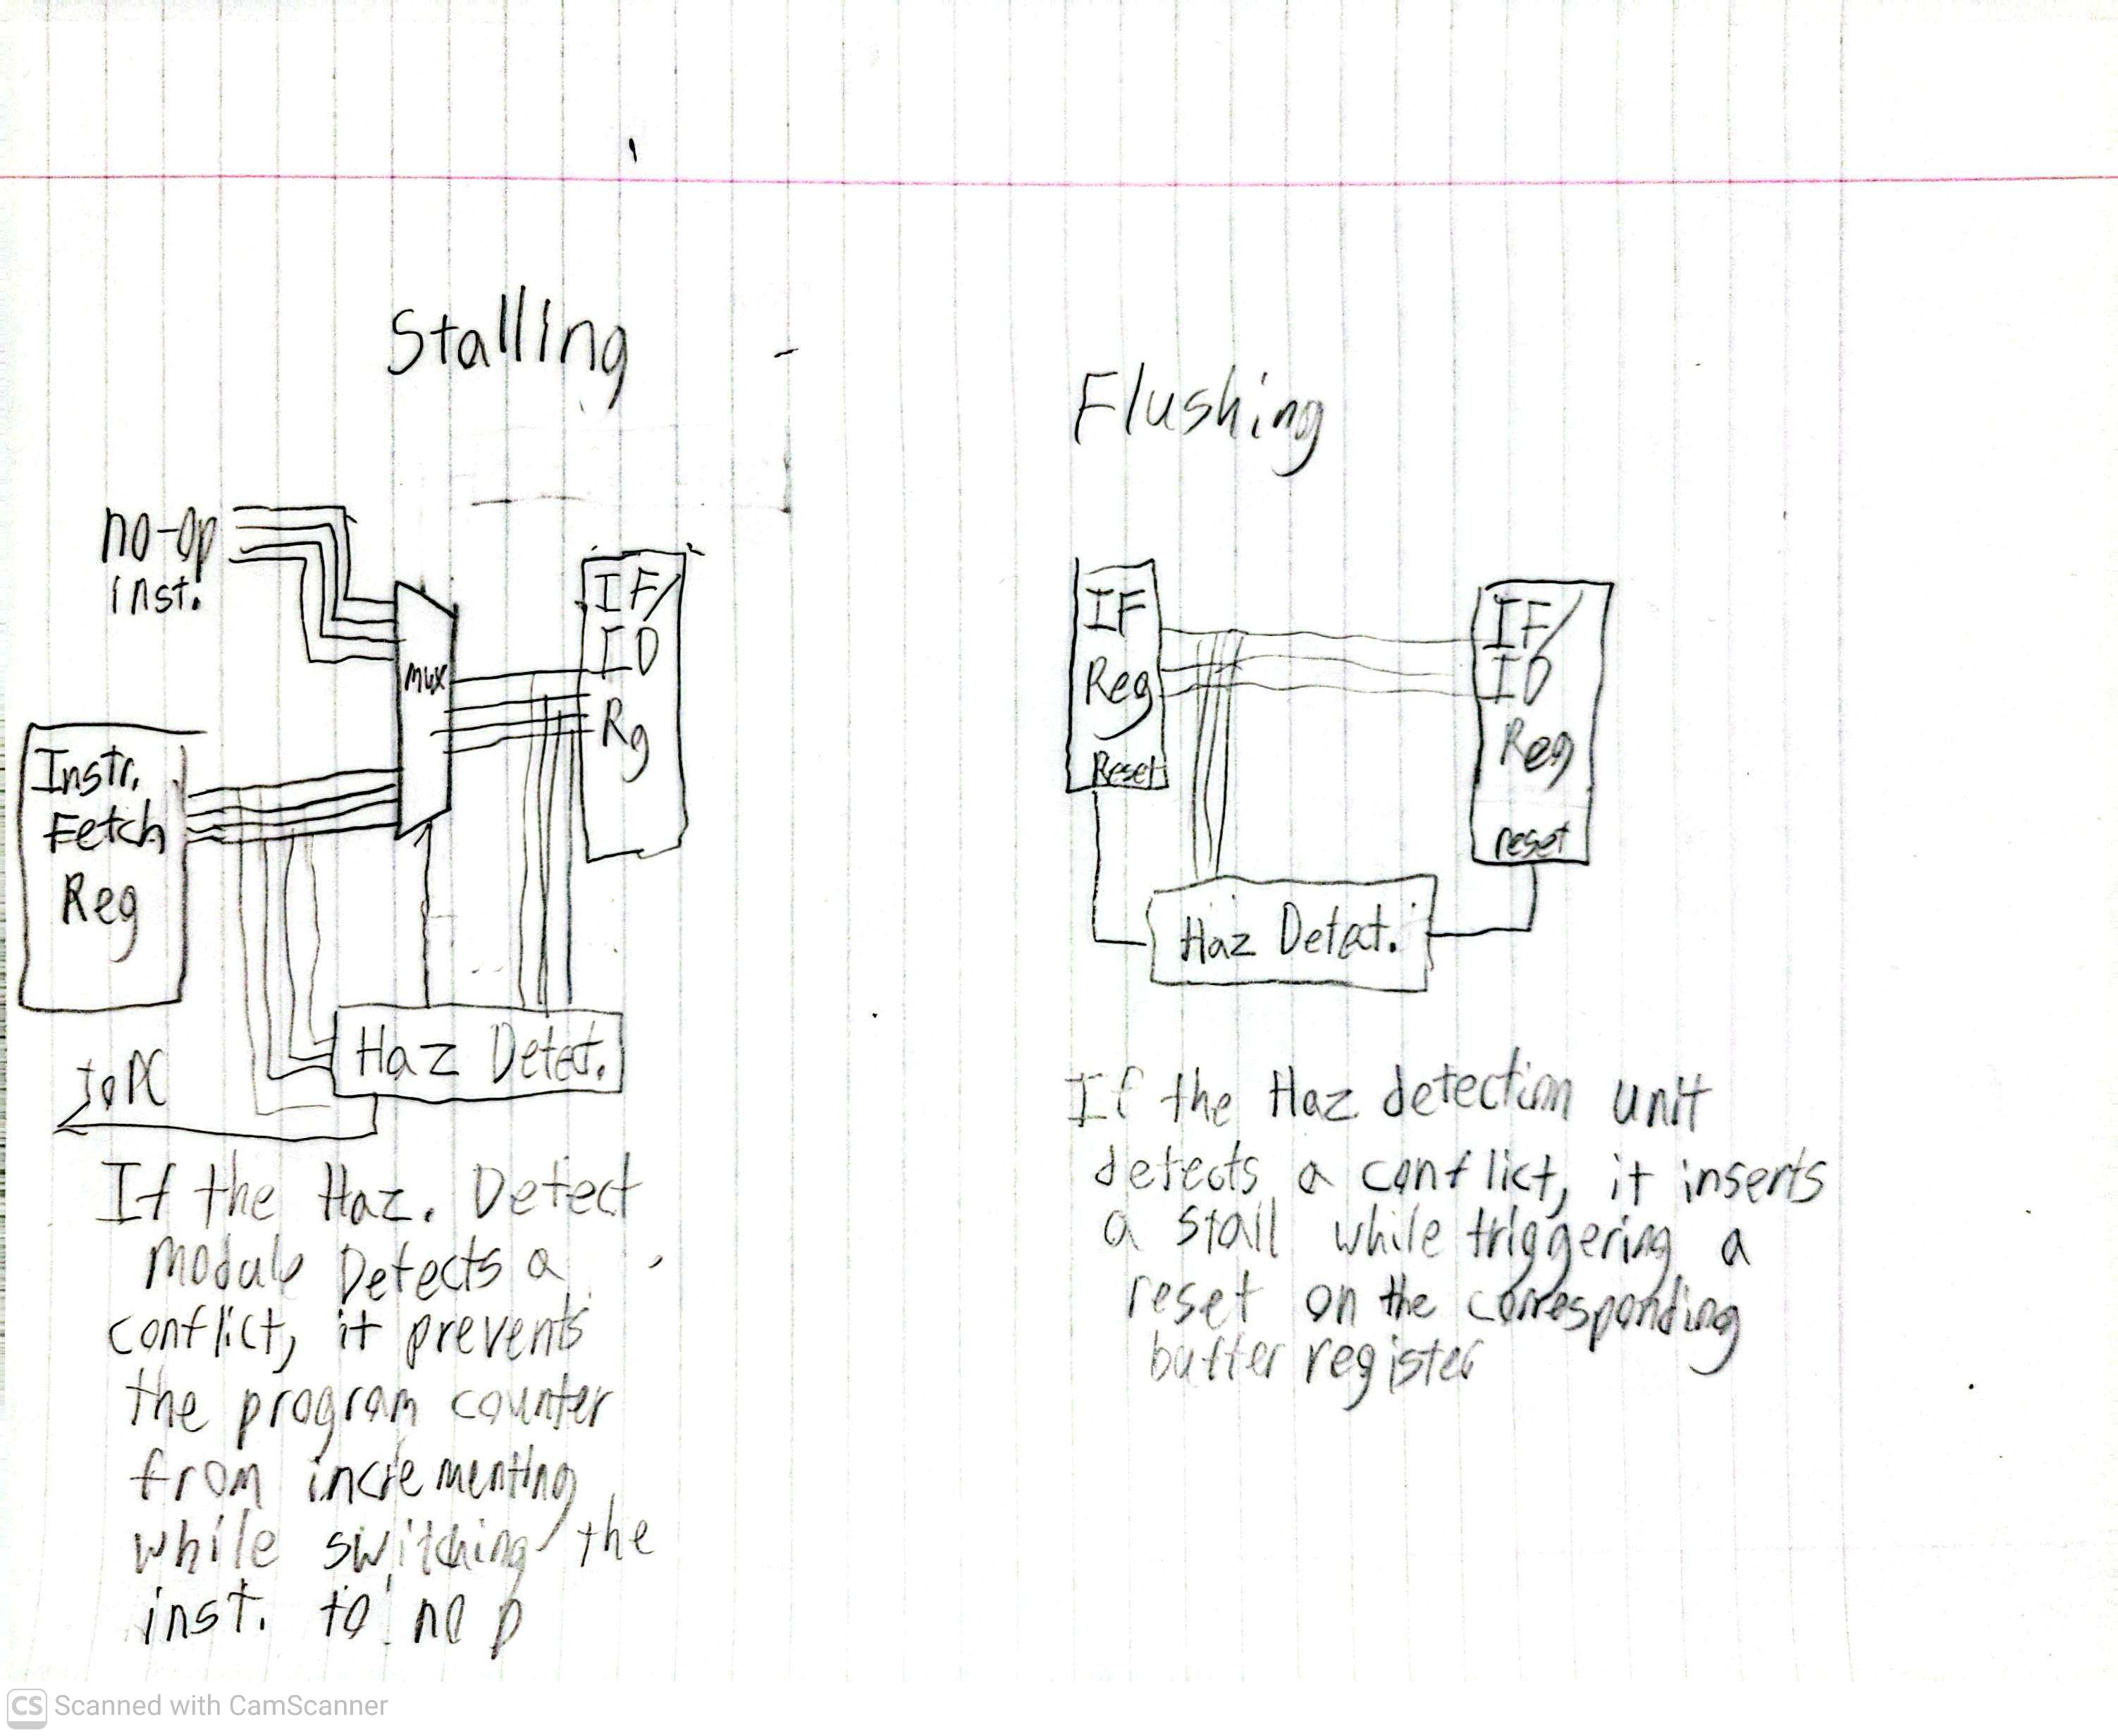

TODO

[2.a.iii] Create a testbench that instantiates all four of the registers in a single design. Show that values that are stored in the initial IF/ID register are available as expected four cycles later, and that new values can be inserted into the pipeline every single cycle. Most importantly, this testbench should also test that each pipeline register can be individually stalled or flushed.

[2.b.i] list which instructions produce values, and what signals (i.e., bus names) in the pipeline these correspond to.

[2.b.ii] List which of these same instructions consume values, and what signals in the pipeline these correspond to.

[2.b.iii] generalized list of potential data dependencies. From this generalized list, select those dependencies that can be forwarded (write down the corresponding pipeline stages that will be forwarding and receiving the data), and those dependencies that will require hazard stalls.

[2.b.iv] global list of the datapath values and control signals that are required during each pipeline stage

IF → ID | ID → EX | EX → MEM | MEM → WB
ProgramCounter | Mem_WE | Mem_WE | MemToReg
Instruction | MemToReg | MemToReg | Reg_WE
i_Reset | Reg_WE | Reg_WE | HaltProg
i_NOP | HaltProg | HaltProg | DMem_Output
 | ALU_Operand1 | RS2 | ALU_Output
 | ALU_Operand2 | ALU_Output | Instruction
 | RS2 | Instruction
 | Instruction
 | ProgramCounter

[2.c.i] list all instructions that may result in a non-sequential PC update and in which pipeline stage that update occurs.

Instruction | Program Counter Update Stage
beq | EX
bne | EX
blt | EX
bge | EX
bltu | EX
bgeu | EX
jal | EX
jalr | EX

[2.c.ii] For these instructions, list which stages need to be stalled and which stages need to be squashed/flushed relative to the stage each of these instructions is in.

Instruction | Stalled | Flushed
beq | IF | ID
bne | IF | ID
blt | IF | ID
bge | IF | ID
bltu | IF | ID
bgeu | IF | ID
jal | IF | ID
jalr | IF | ID

[2.d] implement the hardware-scheduled pipeline using only structural VHDL. As with the previous processors that you have implemented, start with a high-level schematic drawing of the interconnection between components.

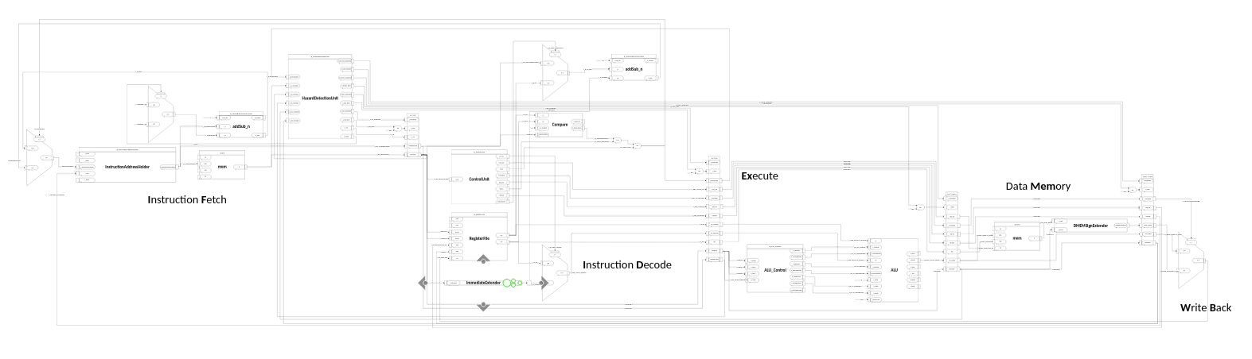
View the full diagram here:
https://iowastate-my.sharepoint.com/:u:/g/personal/esliandy_iastate_edu/IQDs8JdA_jrSTooyfvUJi39XAf79lllUsnsDqnXST-6N5Yo

[2.e – i, ii, and iii] In your writeup, show the QuestaSim output for each of the following tests, and provide a discussion of result correctness. It may be helpful to also annotate the waveforms directly.

[2.e.i] Create a spreadsheet to track these cases and justify the coverage of your testing approach. Include this spreadsheet in your report as a table.

Instruction Type | Produces RD value
Arithmetic | Yes
Immediate Arithmetic | Yes
Load | Only in Writeback stage
Store | No
Branch | No
Jump and Link | Yes
Jump and Link Return | Yes
Lui (Load Upper Immediate) | Yes
Auipc (Add upper immediate to pc) | No
Enviroment | No

[2.e.ii] Create a spreadsheet to track these cases and justify the coverage of your testing approach. Include this spreadsheet in your report as a table.

Instruction Type | Can consume in RS1 | Can consume in RS2
Arithmetic | Yes | Yes
Immediate Arithmetic | Yes | No
Load | Yes | No
Store | Yes | Yes
Branch | No | No
Jump and Link | Yes | No
Jump and Link Return | Yes | No
Lui (Load Upper Immediate) | No | No
Auipc (Add upper immediate to pc) | No | No
Enviroment | No | No

[2.f] report the maximum frequency your hardware-scheduled pipelined processor can run at and determine what your critical path is (specify each module/entity/component that this path goes through).

As the hardware-scheduled processor continue to have errors in the forwarding module, the current frequency is based on purely nop insertion. Thus, the maximum frequency is 51.49mhz

